WEBHOOK IN WOOCOMMERCE

Introduced in WooCommerce 2.1, the REST API allows WooCommerce data to be created, read, updated, and deleted using JSON format.

Detailed Documentation can be found at https://woocommerce.github.io/woocommerce-rest-api-docs/v3.html

API requirements:
You must be using WooCommerce 2.1 or newer and the REST API must be enabled under WooCommerce > Settings. You must enable pretty permalinks in Settings > Permalinks (default permalinks will not work).

REST API End points:

The API is accessible via this endpoint:
http://www.localhost.com/wordpress400/wc-api/v1
http://www.localhost.com/wordpress400/wc-api/v2
http://www.localhost.com/wordpress400/wc-api/v3

Create API key:

Path: WooCommerce > Settings > Advanced > REST API

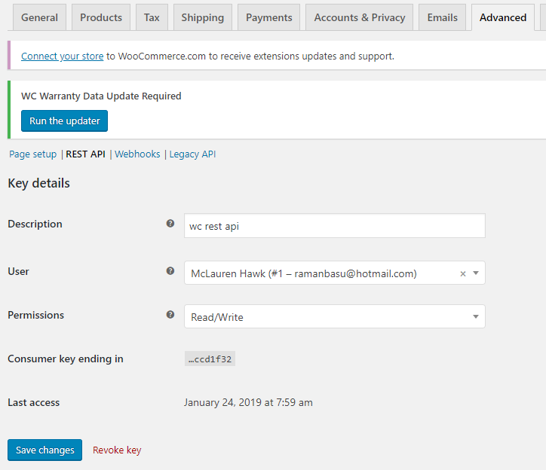

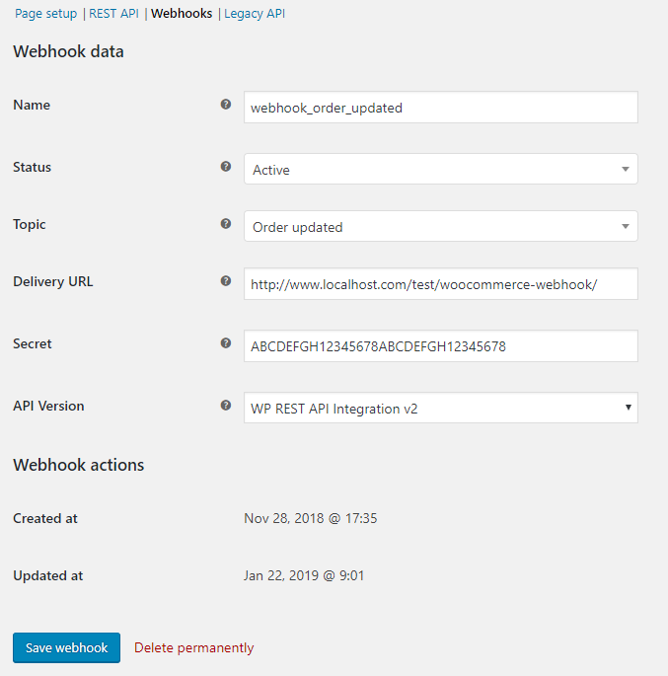

For LocalHost(Test Environment)
Consumer Key: ck_46d55ab59704d99b62af84a49a366575bccd1f32
Consumer Secret: cs_3c750c197060ae3484d1fbadf47ce02bb33a33e8

Each webhook has:
- status: active (delivers payload), paused (delivery paused by admin), disabled (delivery paused by failure)
- topic: determines which resource events the webhook is triggered for
- delivery URL: URL where the payload is delivered, must be HTTP or HTTPS
- secret: an optional secret key that is used to generate a HMAC-SHA256 hash of the request body so the receiver can verify authenticity of the webhook
- hooks: an array of hook names that are added and bound to the webhook for processing

Notes:
- WP REST API Integration v3: not working based on wc_version 3.5.1. V2 API works.

Webhook JSON data received by client(SellerCloud):

{"id":414,"parent_id":0,"number":"OD52","order_key":"wc_order_5bed23d5957ca","created_via":"","version":"3.5.1","status":"on-hold","currency":"USD","date_created":"2018-11-15T07:42:58","date_created_gmt":"2018-11-15T07:42:58","date_modified":"2019-01-04T16:42:38","date_modified_gmt":"2019-01-04T16:42:38","discount_total":"0.00","discount_tax":"0.00","shipping_total":"0.00","shipping_tax":"0.00","cart_tax":"140.00","total":"840.00","total_tax":"140.00","prices_include_tax":false,"customer_id":1,"customer_ip_address":"","customer_user_agent":"","customer_note":"","billing":{"first_name":"McLauren","last_name":"Hawk","company":"Mac Road","address_1":"New Jersey","address_2":"","city":"NJ","state":"NJ","postcode":"08701","country":"US","email":"user1@gmail.com","phone":"9543295432"},"shipping":{"first_name":"McLauren","last_name":"Hawk","company":"Mac Road","address_1":"New Jersey","address_2":"","city":"NJ","state":"NJ","postcode":"08701","country":"US"},"payment_method":"","payment_method_title":"","transaction_id":"","date_paid":"2018-11-29T03:38:26","date_paid_gmt":"2018-11-29T03:38:26","date_completed":"2018-11-29T09:39:11","date_completed_gmt":"2018-11-29T09:39:11","cart_hash":"","meta_data":[{"id":7944,"key":"_order_number","value":"52"},{"id":7945,"key":"_order_number_formatted","value":"OD52"},{"id":7946,"key":"_order_number_meta","value":{"prefix":"OD","suffix":"","length":"1"}}],"line_items":[{"id":357,"name":"Canon PowerShot SX420 Digital Camera w\/ 42x Optical Zoom - Wi-Fi &amp; NFC Enabled (Black)","product_id":265,"variation_id":0,"quantity":2,"tax_class":"","subtotal":"600.00","subtotal_tax":"120.00","total":"600.00","total_tax":"120.00","taxes":[{"id":6,"total":"120","subtotal":"120"}],"meta_data":[{"id":2530,"key":"_item_warranty","value":{"type":"included_warranty","length":"limited","value":"1","duration":"years","label":"Canon USA Warranty"}},{"id":2531,"key":"Canon USA Warranty","value":"Warranty Included (1 Year)"},{"id":2588,"key":"_reduced_stock","value":"2"}],"sku":"CANON","price":300},{"id":359,"name":"Sample Smart Glove 1","product_id":29,"variation_id":0,"quantity":10,"tax_class":"","subtotal":"100.00","subtotal_tax":"20.00","total":"100.00","total_tax":"20.00","taxes":[{"id":6,"total":"20","subtotal":"20"}],"meta_data":[{"id":2589,"key":"_reduced_stock","value":"10"}],"sku":"SAM002","price":10}],"tax_lines":[{"id":358,"rate_code":"TAX-1","rate_id":6,"label":"Tax","compound":false,"tax_total":"140.00","shipping_tax_total":"0.00","meta_data":[]}],"shipping_lines":[],"fee_lines":[],"coupon_lines":[],"refunds":[]}

Request Headers:
Array
(
[Host] => www.localhost.com
[User-Agent] => WooCommerce/3.5.1 Hookshot (WordPress/4.9.9)
[Accept] => */*
[Accept-Encoding] => deflate, gzip
[Referer] => http://www.localhost.com/test/woocommerce-webhook/
[Content-Type] => application/json

[X-WC-Webhook-Source] => http://www.localhost.com/wordpress400/
[X-WC-Webhook-Topic] => order.updated
[X-WC-Webhook-Resource] => order
[X-WC-Webhook-Event] => updated
[X-WC-Webhook-Signature] => xt0YxtFZEwbGgwpz7riTuImdVa7vSb9HdreW8udF4mg=
[X-WC-Webhook-ID] => 1
[X-WC-Webhook-Delivery-ID] => 4ae5643ee90b9cf84a0bc669fcae1837
[Connection] => close
[Content-Length] => 2581
[Expect] => 100-continue
)

WC Order updated

WC posts data to delivery Url (xx.cwa.sellercloud.com/WebhookReceiver.aspx)
[Request] => Array
(
[Method] => POST
[Headers] => Array
(
[User-Agent] => WooCommerce/3.5.1 Hookshot (WordPress/4.9.8)
[Content-Type] => application/json
[X-WC-Webhook-Source] => http://www.localhost.com/wordpress400/
[X-WC-Webhook-Topic] => order.updated
[X-WC-Webhook-Resource] => order
[X-WC-Webhook-Event] => updated
[X-WC-Webhook-Signature] => V0fSIPfHxpj0bzdj29Hr9iNZEVuxnYIEJXhNZ8JOhrc=
[X-WC-Webhook-ID] => 1
[X-WC-Webhook-Delivery-ID] => f910cd747aa8ae63f81eb6c56ac86551
)

)

Post data request header contains [X-WC-Webhook-Source] which is WC store Url.

Match [X-WC-Webhook-Source] to find the target SC Company ID.

REST API LOGS
WooCommerce > Status > Logs
http://www.localhost.com/wordpress400/wp-admin/admin.php?page=wc-status&tab=logs

Endpoints
List of webhooks:
V2:
https://www.localhost.com/wordpress400/wc-api/v2/webhooks?consumer_key=ck_46d55ab59704d99b62af84a49a366575bccd1f32&consumer_secret=cs_3c750c197060ae3484d1fbadf47ce02bb33a33e8

V3:
https://www.localhost.com/wordpress400/wc-api/v3/webhooks?consumer_key=ck_46d55ab59704d99b62af84a49a366575bccd1f32&consumer_secret=cs_3c750c197060ae3484d1fbadf47ce02bb33a33e8

